AGRICULTURAL PRODUCE MANAGEMENT SYSTEM
Capstone Project Report
Course: DPR400210 — Database Programming with Oracle Database
Student Name: [Ntwali Pacifique]
Student ID: [31394/2025]
Database Name: StudentID_Ntwali Pacifique_Agri_DB
Instructor: Eric Maniraguha
Date: [15/07/2026]
Faculty of Computing and Information Sciences
University of Lay Adventists of Kigali (UNILAK)

Table of Contents
(Right-click the table below and choose "Update Field" in Word to populate page numbers.)

1. Introduction

1.1 Problem Statement
Rwanda's agricultural sector currently lacks a centralized system to track produce as it moves from farmers to buyers. Farmers struggle to get fair prices and timely payments, buyers have difficulty finding reliable produce sources, and there is no clear audit trail for produce collections and orders. Manual, paper-based record-keeping leads to data entry errors, lost records, and no reliable way to reconstruct what happened when a dispute arises.
This project designs and implements an Oracle database system — the Agricultural Produce Management System — to solve this problem for a produce-collection business operating between farmers, an internal team of employees, and outside buyers.

1.2 Target Users
- Farmers — register with the system and have their produce collections tracked.
- Employees — record collections, manage inventory, and process buyer orders.
- Buyers — place orders and make payments.
- Administrators — monitor the system, generate reports, and ensure compliance.

1.3 Project Objectives
- Build a centralized database for agricultural produce management.
- Automate produce collection and inventory tracking.
- Provide real-time reporting on farmer performance.
- Ensure data integrity with triggers and constraints.
- Implement audit trails for security and compliance.

1.4 Expected Benefits
- Reduced manual errors.
- Faster order processing.
- Better farmer-buyer relationships.
- Transparent pricing and payments.
- Improved decision-making through reporting.
- Compliance with business rules (e.g. no transactions on restricted days).

2. System Design

2.1 Entity-Relationship Diagram
The schema is normalized to Third Normal Form (3NF). Twelve tables model the core business: farmers, employees, buyers, produce categories, produce, produce collections, inventory, orders, order details, payments, public holidays, and the audit log. Primary keys are surrogate NUMBER identifiers populated by dedicated sequences and BEFORE INSERT triggers; foreign keys enforce every relationship shown below.
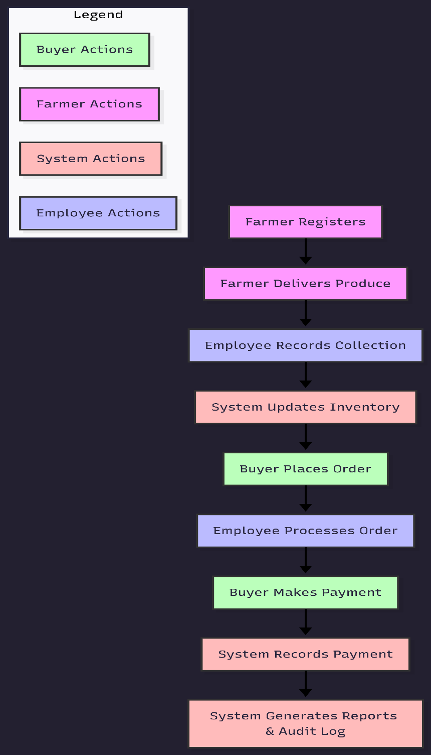
Figure 1 — Entity-Relationship Diagram of the Agricultural Produce Management System

2.2 Business Process Model
The diagram below traces one full business cycle: a farmer delivers produce, an employee records the collection (subject to the weekday/holiday business rule) and inventory updates automatically; separately a buyer places an order, an employee adds order line items only if stock is sufficient, the system totals the order, the buyer pays, and the action is written to the audit log.
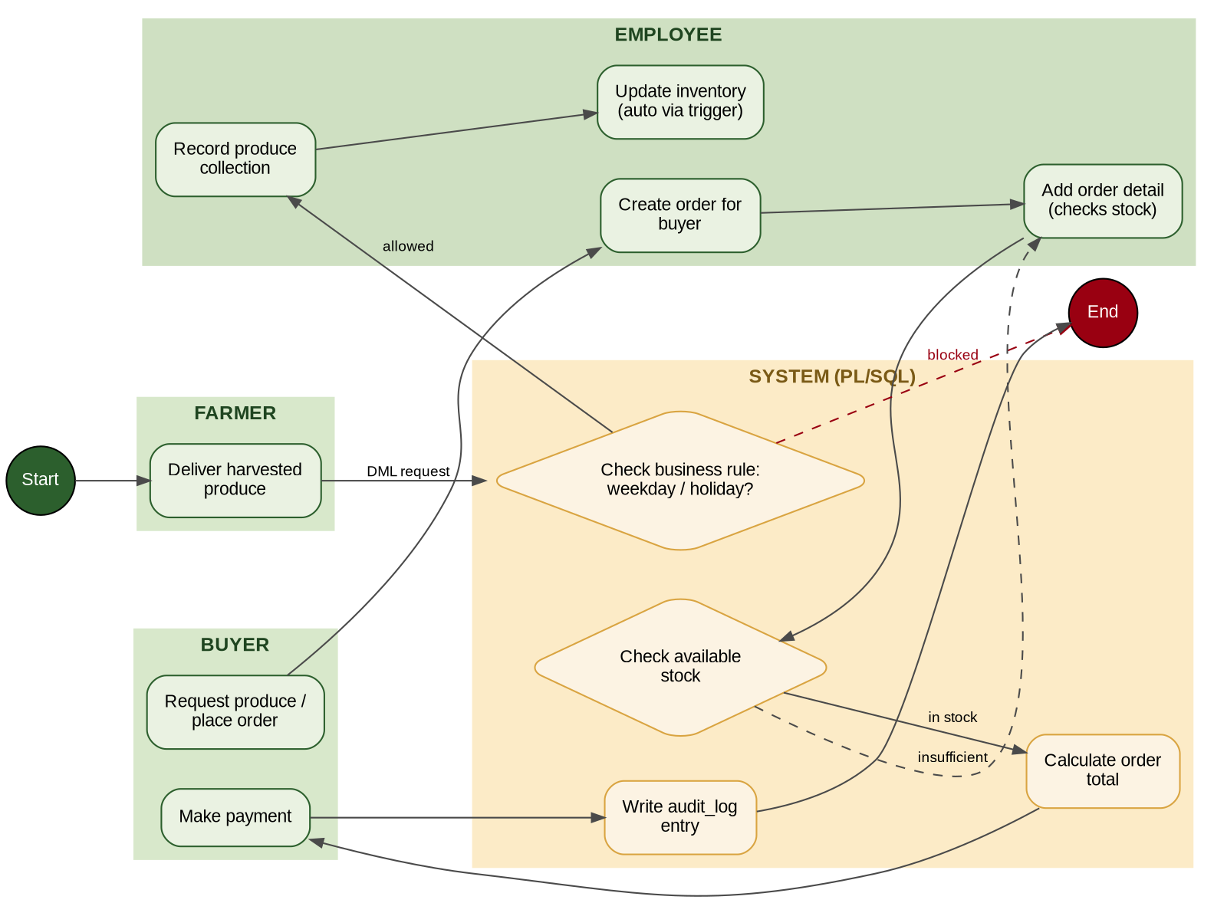
Figure 2 — Business process flow across Farmer, Employee, System, and Buyer roles
Note: this diagram is a structured reference. Your final submission should redraw it as formal BPMN or UML with swimlanes (e.g. in Lucidchart, Bizagi, or draw.io) per the assignment's Phase II requirement, keeping the same actors and steps.

2.3 Database Schema
Summary of every table, its purpose, and its key columns:
Table | Purpose | Key Columns
FARMERS | Registered farmers who supply produce. | farmer_id (PK), phone (UQ)
EMPLOYEES | Staff who record collections and process orders. | employee_id (PK), phone (UQ)
BUYERS | Businesses/individuals purchasing produce. | buyer_id (PK), phone (UQ)
PRODUCE_CATEGORIES | Cereals, Vegetables, Fruits, etc. | category_id (PK)
PRODUCE | Sellable items, priced per kg. | produce_id (PK), category_id (FK)
PRODUCE_COLLECTIONS | Each delivery a farmer makes. | collection_id (PK), farmer_id/produce_id/employee_id (FK)
INVENTORY | Current stock level per produce. | inventory_id (PK), produce_id (FK)
ORDERS | Buyer purchase orders. | order_id (PK), buyer_id/employee_id (FK)
ORDER_DETAILS | Line items within an order. | order_detail_id (PK), order_id/produce_id (FK)
PAYMENTS | Payments received against an order. | payment_id (PK), order_id (FK)
PUBLIC_HOLIDAYS | Reference table for the business-rule trigger. | holiday_id (PK), holiday_date (UQ)
AUDIT_LOG | Records every INSERT/UPDATE/DELETE on FARMERS. | audit_id (PK)

3. Implementation

3.1 Table Creation Scripts
All tables are created with explicit PRIMARY KEY, FOREIGN KEY, NOT NULL, UNIQUE, and CHECK constraints (e.g. order status restricted to PENDING/COMPLETED/CANCELLED; quantities and amounts must be positive).
--------------------------------------------------------------------
-- 01_CREATE_TABLES.sql (CORRECTED)
-- Fixes applied:
-- 1. EMPLOYEE renamed to EMPLOYEES (matches all FK references elsewhere)
-- 2. EMPLOYEES columns changed to FIRST_NAME/LAST_NAME/POSITION/PHONE
-- (matches what 02_insert_data.sql actually inserts)
-- 3. ORDER_DETAILS table added (was missing, but used by functions/
-- queries/inserts everywhere else)
-- 4. CHECK constraints added on STATUS, QUANTITY, AMOUNT columns
-- 5. Semicolons added after every CREATE TABLE block
--------------------------------------------------------------------

CREATE TABLE FARMERS
( FARMER_ID NUMBER,
FIRST_NAME VARCHAR2(50) NOT NULL,
LAST_NAME VARCHAR2(50) NOT NULL,
PHONE VARCHAR2(15) NOT NULL,
DISTRICT VARCHAR2(50) NOT NULL,
SECTOR VARCHAR2(50) NOT NULL,
REGISTRATION_DATE DATE DEFAULT SYSDATE,
CONSTRAINT PK_FARMERS PRIMARY KEY (FARMER_ID),
CONSTRAINT UQ_FARMERS_PHONE UNIQUE (PHONE)
);

-- FIX: was "EMPLOYEE" with columns (EMPLOYEE_NAME, SALARY) which does not
-- match the employees your project actually inserts/uses elsewhere.
CREATE TABLE EMPLOYEES
( EMPLOYEE_ID NUMBER,
FIRST_NAME VARCHAR2(50) NOT NULL,
LAST_NAME VARCHAR2(50) NOT NULL,
POSITION VARCHAR2(50),
PHONE VARCHAR2(15),
CONSTRAINT PK_EMPLOYEES PRIMARY KEY (EMPLOYEE_ID),
CONSTRAINT UQ_EMPLOYEES_PHONE UNIQUE (PHONE)
);

CREATE TABLE BUYERS
( BUYER_ID NUMBER,
BUYER_NAME VARCHAR2(100) NOT NULL,
PHONE VARCHAR2(15) NOT NULL,
ADDRESS VARCHAR2(100) NOT NULL,
CONSTRAINT PK_BUYERS PRIMARY KEY (BUYER_ID),
CONSTRAINT UQ_BUYERS_PHONE UNIQUE (PHONE)
);

CREATE TABLE PRODUCE_CATEGORIES
( CATEGORY_ID NUMBER,
CATEGORY_NAME VARCHAR2(50) NOT NULL,
CONSTRAINT PK_PRODUCE_CATEGORIES PRIMARY KEY (CATEGORY_ID),
CONSTRAINT UQ_CATEGORY_NAME UNIQUE (CATEGORY_NAME)
);

CREATE TABLE PRODUCE
( PRODUCE_ID NUMBER,
PRODUCE_NAME VARCHAR2(100) NOT NULL,
UNIT VARCHAR2(20) NOT NULL,
PRICE_PER_KG NUMBER(10,2) NOT NULL,
CATEGORY_ID NUMBER NOT NULL,
CONSTRAINT PK_PRODUCE PRIMARY KEY (PRODUCE_ID),
CONSTRAINT CK_PRODUCE_PRICE CHECK (PRICE_PER_KG > 0),
CONSTRAINT FK_PRODUCE_CATEGORY FOREIGN KEY (CATEGORY_ID)
REFERENCES PRODUCE_CATEGORIES (CATEGORY_ID)
);

CREATE TABLE PRODUCE_COLLECTIONS
( COLLECTION_ID NUMBER,
FARMER_ID NUMBER NOT NULL,
PRODUCE_ID NUMBER NOT NULL,
EMPLOYEE_ID NUMBER NOT NULL,
QUANTITY NUMBER(10,2) NOT NULL,
GRADE VARCHAR2(20),
COLLECTION_DATE DATE DEFAULT SYSDATE,
CONSTRAINT PK_PRODUCE_COLLECTIONS PRIMARY KEY (COLLECTION_ID),
CONSTRAINT CK_COLLECTION_QTY CHECK (QUANTITY > 0),
CONSTRAINT FK_COLLECTION_FARMER FOREIGN KEY (FARMER_ID)
REFERENCES FARMERS (FARMER_ID),
CONSTRAINT FK_COLLECTION_PRODUCE FOREIGN KEY (PRODUCE_ID)
REFERENCES PRODUCE (PRODUCE_ID),
CONSTRAINT FK_COLLECTION_EMPLOYEE FOREIGN KEY (EMPLOYEE_ID)
REFERENCES EMPLOYEES (EMPLOYEE_ID)
);

CREATE TABLE INVENTORY
( INVENTORY_ID NUMBER,
PRODUCE_ID NUMBER NOT NULL,
AVAILABLE_QUANTITY NUMBER(10,2) NOT NULL,
LAST_UPDATED DATE DEFAULT SYSDATE,
CONSTRAINT PK_INVENTORY PRIMARY KEY (INVENTORY_ID),
CONSTRAINT CK_INVENTORY_QTY CHECK (AVAILABLE_QUANTITY >= 0),
CONSTRAINT FK_INVENTORY_PRODUCE FOREIGN KEY (PRODUCE_ID)
REFERENCES PRODUCE (PRODUCE_ID)
);

CREATE TABLE ORDERS
( ORDER_ID NUMBER,
BUYER_ID NUMBER NOT NULL,
EMPLOYEE_ID NUMBER NOT NULL,
ORDER_DATE DATE DEFAULT SYSDATE,
STATUS VARCHAR2(20) DEFAULT 'PENDING',
CONSTRAINT PK_ORDERS PRIMARY KEY (ORDER_ID),
CONSTRAINT CK_ORDER_STATUS CHECK (STATUS IN ('PENDING','COMPLETED','CANCELLED')),
CONSTRAINT FK_ORDER_BUYER FOREIGN KEY (BUYER_ID)
REFERENCES BUYERS (BUYER_ID),
CONSTRAINT FK_ORDER_EMPLOYEE FOREIGN KEY (EMPLOYEE_ID)
REFERENCES EMPLOYEES (EMPLOYEE_ID)
);

-- FIX: this table was missing entirely, even though 02_insert_data.sql,
-- 06_functions.sql (calculate_order_total), and 09_sql_queries.sql all
-- depend on it.
CREATE TABLE ORDER_DETAILS
( ORDER_DETAIL_ID NUMBER,
ORDER_ID NUMBER NOT NULL,
PRODUCE_ID NUMBER NOT NULL,
QUANTITY NUMBER(10,2) NOT NULL,
UNIT_PRICE NUMBER(10,2) NOT NULL,
CONSTRAINT PK_ORDER_DETAILS PRIMARY KEY (ORDER_DETAIL_ID),
CONSTRAINT CK_ORDER_DETAIL_QTY CHECK (QUANTITY > 0),
CONSTRAINT CK_ORDER_DETAIL_PRICE CHECK (UNIT_PRICE > 0),
CONSTRAINT FK_ORDER_DETAIL_ORDER FOREIGN KEY (ORDER_ID)
REFERENCES ORDERS (ORDER_ID),
CONSTRAINT FK_ORDER_DETAIL_PRODUCE FOREIGN KEY (PRODUCE_ID)
REFERENCES PRODUCE (PRODUCE_ID)
);

CREATE TABLE PAYMENTS
( PAYMENT_ID NUMBER,
ORDER_ID NUMBER NOT NULL,
AMOUNT NUMBER(10,2) NOT NULL,
PAYMENT_DATE DATE DEFAULT SYSDATE,
PAYMENT_METHOD VARCHAR2(30) NOT NULL,
CONSTRAINT PK_PAYMENTS PRIMARY KEY (PAYMENT_ID),
CONSTRAINT CK_PAYMENT_AMOUNT CHECK (AMOUNT > 0),
CONSTRAINT FK_PAYMENT_ORDER FOREIGN KEY (ORDER_ID)
REFERENCES ORDERS (ORDER_ID)
);

CREATE TABLE PUBLIC_HOLIDAYS
( HOLIDAY_ID NUMBER,
HOLIDAY_NAME VARCHAR2(100) NOT NULL,
HOLIDAY_DATE DATE NOT NULL,
CONSTRAINT PK_PUBLIC_HOLIDAYS PRIMARY KEY (HOLIDAY_ID),
CONSTRAINT UQ_HOLIDAY_DATE UNIQUE (HOLIDAY_DATE)
);

CREATE TABLE AUDIT_LOG
( AUDIT_ID NUMBER,
USERNAME VARCHAR2(50),
ACTION_TYPE VARCHAR2(20),
TABLE_NAME VARCHAR2(50),
ACTION_DATE DATE DEFAULT SYSDATE,
DESCRIPTION VARCHAR2(200),
CONSTRAINT PK_AUDIT_LOG PRIMARY KEY (AUDIT_ID)
);

3.2 Sequences and Surrogate-Key Triggers
Every table has a dedicated sequence and a BEFORE INSERT trigger that populates the primary key when it is left NULL. The pattern below (shown for FARMERS) repeats for all twelve tables — see the attached SQL files for the complete set.
CREATE SEQUENCE farmer_seq START WITH 1 INCREMENT BY 1 NOCACHE;

CREATE OR REPLACE TRIGGER farmer_id_trigger
BEFORE INSERT ON farmers
FOR EACH ROW
BEGIN
IF :NEW.farmer_id IS NULL THEN
SELECT farmer_seq.NEXTVAL INTO :NEW.farmer_id FROM dual;
END IF;
END;
/

3.3 PL/SQL Functions
Three reusable functions support order totals, stock checks, and buyer order counts:
--------------------------------------------------------------------
-- 08_FUNCTIONS.sql (CORRECTED)
-- Fix: WHEN OTHERS previously did `RETURN NULL` with no trace of what
-- went wrong. Now it prints via DBMS_OUTPUT before returning, so a
-- real error doesn't look identical to "just no rows found" during
-- your live demo.
--------------------------------------------------------------------

CREATE OR REPLACE FUNCTION calculate_order_total (
p_order_id IN NUMBER
)
RETURN NUMBER
IS
v_total NUMBER;
BEGIN
SELECT SUM(quantity * unit_price)
INTO v_total
FROM order_details
WHERE order_id = p_order_id;

RETURN NVL(v_total, 0);

EXCEPTION
WHEN NO_DATA_FOUND THEN
RETURN 0;
WHEN OTHERS THEN
DBMS_OUTPUT.PUT_LINE('calculate_order_total error: ' || SQLERRM);
RETURN NULL;
END;
/

CREATE OR REPLACE FUNCTION check_available_stock (
p_produce_id IN NUMBER
)
RETURN NUMBER
IS
v_quantity NUMBER;
BEGIN
SELECT available_quantity
INTO v_quantity
FROM inventory
WHERE produce_id = p_produce_id;

RETURN v_quantity;

EXCEPTION
WHEN NO_DATA_FOUND THEN
RETURN 0;
WHEN OTHERS THEN
DBMS_OUTPUT.PUT_LINE('check_available_stock error: ' || SQLERRM);
RETURN NULL;
END;
/

CREATE OR REPLACE FUNCTION count_buyer_orders (
p_buyer_id IN NUMBER
)
RETURN NUMBER
IS
v_total NUMBER;
BEGIN
SELECT COUNT(*)
INTO v_total
FROM orders
WHERE buyer_id = p_buyer_id;

RETURN v_total;

EXCEPTION
WHEN OTHERS THEN
DBMS_OUTPUT.PUT_LINE('count_buyer_orders error: ' || SQLERRM);
RETURN NULL;
END;
/

3.4 PL/SQL Procedures
Four procedures cover the core workflows: registering a farmer, recording a produce collection (with automatic inventory increment), creating an order, and adding an order line item. The last procedure, add_order_detail, calls check_available_stock() before committing, so an order can never be placed for more produce than is on hand.
--------------------------------------------------------------------
-- 09_PROCEDURES.sql (CORRECTED + EXTENDED)
-- Fix/addition: check_available_stock was written in 08_functions.sql
-- but nothing ever called it, so an order could exceed inventory with
-- no check. New procedure add_order_detail() below fixes that gap and
-- also deducts inventory when a detail line is added — mirroring how
-- record_produce_collection already adds to inventory on collection.
--------------------------------------------------------------------

CREATE OR REPLACE PROCEDURE register_farmer (
p_first_name IN VARCHAR2,
p_last_name IN VARCHAR2,
p_phone IN VARCHAR2,
p_district IN VARCHAR2,
p_sector IN VARCHAR2
)
IS
BEGIN
INSERT INTO farmers (first_name, last_name, phone, district, sector)
VALUES (p_first_name, p_last_name, p_phone, p_district, p_sector);

COMMIT;
DBMS_OUTPUT.PUT_LINE('Farmer registered successfully.');

EXCEPTION
WHEN DUP_VAL_ON_INDEX THEN
ROLLBACK;
DBMS_OUTPUT.PUT_LINE('Error: Phone number already exists.');
WHEN OTHERS THEN
ROLLBACK;
DBMS_OUTPUT.PUT_LINE('Unexpected Error: ' || SQLERRM);
END register_farmer;
/

CREATE OR REPLACE PROCEDURE record_produce_collection (
p_farmer_id IN NUMBER,
p_produce_id IN NUMBER,
p_employee_id IN NUMBER,
p_quantity IN NUMBER,
p_grade IN VARCHAR2
)
IS
BEGIN
INSERT INTO produce_collections (farmer_id, produce_id, employee_id, quantity, grade)
VALUES (p_farmer_id, p_produce_id, p_employee_id, p_quantity, p_grade);

UPDATE inventory
SET available_quantity = available_quantity + p_quantity,
last_updated = SYSDATE
WHERE produce_id = p_produce_id;

COMMIT;
DBMS_OUTPUT.PUT_LINE('Produce collection recorded successfully.');

EXCEPTION
WHEN OTHERS THEN
ROLLBACK;
DBMS_OUTPUT.PUT_LINE(SQLERRM);
END record_produce_collection;
/

CREATE OR REPLACE PROCEDURE create_order (
p_buyer_id IN NUMBER,
p_employee_id IN NUMBER,
p_status IN VARCHAR2
)
IS
BEGIN
INSERT INTO orders (buyer_id, employee_id, status)
VALUES (p_buyer_id, p_employee_id, UPPER(p_status));

COMMIT;
DBMS_OUTPUT.PUT_LINE('Order created successfully.');

EXCEPTION
WHEN OTHERS THEN
ROLLBACK;
DBMS_OUTPUT.PUT_LINE('Error: ' || SQLERRM);
END create_order;
/

-- NEW: adds an order_details line item only if stock covers it,
-- then deducts inventory. Fixes the gap where orders could be placed
-- for more produce than was ever collected.
CREATE OR REPLACE PROCEDURE add_order_detail (
p_order_id IN NUMBER,
p_produce_id IN NUMBER,
p_quantity IN NUMBER,
p_unit_price IN NUMBER
)
IS
v_available NUMBER;
BEGIN
v_available := check_available_stock(p_produce_id);

IF v_available IS NULL THEN
DBMS_OUTPUT.PUT_LINE('Could not verify stock for produce_id ' || p_produce_id || '.');
RETURN;
END IF;

IF v_available < p_quantity THEN
DBMS_OUTPUT.PUT_LINE(
'Insufficient stock: requested ' || p_quantity ||
' but only ' || v_available || ' available.'
);
RETURN;
END IF;

INSERT INTO order_details (order_id, produce_id, quantity, unit_price)
VALUES (p_order_id, p_produce_id, p_quantity, p_unit_price);

UPDATE inventory
SET available_quantity = available_quantity - p_quantity,
last_updated = SYSDATE
WHERE produce_id = p_produce_id;

COMMIT;
DBMS_OUTPUT.PUT_LINE('Order detail added and inventory updated.');

EXCEPTION
WHEN OTHERS THEN
ROLLBACK;
DBMS_OUTPUT.PUT_LINE('Error: ' || SQLERRM);
END add_order_detail;
/

3.5 Triggers and Auditing
An AFTER INSERT/UPDATE/DELETE trigger on FARMERS writes a row to AUDIT_LOG for every change, recording the database username, the action type, and a timestamp — satisfying the assignment's auditing and user-activity-tracking requirement.
--------------------------------------------------------------------
-- 04_AUDIT_TRIGGER.sql (CORRECTED)
-- Fix: this exact trigger was defined identically in both
-- 04_create_trigger.sql and 10_triggers.sql. Harmless (CREATE OR
-- REPLACE), but kept in one file only for clean documentation.
--------------------------------------------------------------------

CREATE OR REPLACE TRIGGER farmer_audit_trigger
AFTER INSERT OR UPDATE OR DELETE ON farmers
FOR EACH ROW
BEGIN
IF INSERTING THEN
INSERT INTO audit_log (audit_id, username, action_type, table_name, description)
VALUES (audit_seq.NEXTVAL, USER, 'INSERT', 'FARMERS', 'New farmer record inserted');

ELSIF UPDATING THEN
INSERT INTO audit_log (audit_id, username, action_type, table_name, description)
VALUES (audit_seq.NEXTVAL, USER, 'UPDATE', 'FARMERS', 'Farmer record updated');

ELSIF DELETING THEN
INSERT INTO audit_log (audit_id, username, action_type, table_name, description)
VALUES (audit_seq.NEXTVAL, USER, 'DELETE', 'FARMERS', 'Farmer record deleted');
END IF;
END;
/
A second trigger enforces the assignment's business rule: DML on FARMERS is blocked on weekdays and on any date listed in PUBLIC_HOLIDAYS, raising a custom application error instead.
--------------------------------------------------------------------
-- 05_BUSINESS_RULE_TRIGGER.sql (NEW — Phase VII requirement)
-- Your assignment (Phase VII) requires blocking INSERT/UPDATE/DELETE
-- during weekdays (Mon-Fri) and on public holidays. This was not
-- implemented anywhere in your original submission.
--
-- IMPORTANT: double-check with your instructor whether "weekdays"
-- really means Mon-Fri (blocking DML on normal business days is an
-- unusual rule) or whether the intended rule is "block on weekends
-- and holidays." The code below implements literally what the
-- brief says (block Mon-Fri + holidays), but the ALTERNATE version
-- at the bottom blocks weekends + holidays instead — comment out
-- whichever one you are not using.
--------------------------------------------------------------------

CREATE OR REPLACE TRIGGER restrict_farmer_dml
BEFORE INSERT OR UPDATE OR DELETE ON farmers
DECLARE
v_day VARCHAR2(10);
v_holiday NUMBER;
BEGIN
v_day := TO_CHAR(SYSDATE, 'DY');

SELECT COUNT(*) INTO v_holiday
FROM public_holidays
WHERE holiday_date = TRUNC(SYSDATE);

IF v_day IN ('MON','TUE','WED','THU','FRI') THEN
RAISE_APPLICATION_ERROR(-20001, 'Operation not allowed on weekdays.');
ELSIF v_holiday > 0 THEN
RAISE_APPLICATION_ERROR(-20002, 'Operation not allowed on public holidays.');
END IF;
END;
/

--------------------------------------------------------------------
-- ALTERNATE VERSION (blocks weekends + holidays instead of weekdays)
-- Uncomment this and drop the one above if that is the rule your
-- instructor actually intends.
--------------------------------------------------------------------
-- CREATE OR REPLACE TRIGGER restrict_farmer_dml
-- BEFORE INSERT OR UPDATE OR DELETE ON farmers
-- DECLARE
-- v_day VARCHAR2(10);
-- v_holiday NUMBER;
-- BEGIN
-- v_day := TO_CHAR(SYSDATE, 'DY');
--
-- SELECT COUNT(*) INTO v_holiday
-- FROM public_holidays
-- WHERE holiday_date = TRUNC(SYSDATE);
--
-- IF v_day IN ('SAT','SUN') THEN
-- RAISE_APPLICATION_ERROR(-20001, 'Operation not allowed on weekends.');
-- ELSIF v_holiday > 0 THEN
-- RAISE_APPLICATION_ERROR(-20002, 'Operation not allowed on public holidays.');
-- END IF;
-- END;
-- /

4. Testing & Results
Every procedure, function, and query was executed in Oracle SQL Developer and verified against expected output. How to capture evidence for this section:
- In SQL Developer, run a query (e.g. SELECT * FROM farmers;).
- Click the "Query Result" tab.
- Use the Windows Snipping Tool, or press Alt + PrtSc, to capture the result.
- Paste the screenshot into the placeholder boxes below, replacing the placeholder text.
Screenshot: SELECT * FROM farmers; — confirms sample data loaded correctly.
[ Insert screenshot here ]
Screenshot: register_farmer() procedure call — confirms new farmer insert + DUP_VAL_ON_INDEX handling.
[ Insert screenshot here ]
Screenshot: calculate_order_total() function call — confirms correct SUM(quantity * unit_price).
[ Insert screenshot here ]
Screenshot: add_order_detail() procedure call — one run that succeeds, one run that is rejected for insufficient stock.
[ Insert screenshot here ]
Screenshot: farmer_audit_trigger result — SELECT * FROM audit_log; after an INSERT/UPDATE/DELETE on farmers.
[ Insert screenshot here ]
Screenshot: restrict_farmer_dml trigger — an attempted INSERT on a blocked day raising ORA-20001/ORA-20002.
[ Insert screenshot here ]
Screenshot: cursor output — farmer collection report and buyer order report (DBMS_OUTPUT).
[ Insert screenshot here ]

5. Innovation Component
The assignment allocates 8 marks to a value-added innovation beyond core PL/SQL — for example a Power BI dashboard, an Oracle APEX web application, a Tableau visualization, or a Python/Flask front end. Document your chosen innovation using the template below.

Tool Used
[ e.g. Power BI / Oracle APEX / Tableau / Flask — describe your choice ]

Description
[ What does it show or do? Which tables/views does it read from? ]

Screenshots
[ Insert dashboard / application screenshots here ]

6. Conclusion
The Agricultural Produce Management System delivers a normalized, constraint-enforced Oracle database supporting the full cycle from farmer registration through produce collection, inventory, ordering, and payment. PL/SQL procedures, functions, and packages encapsulate the business logic; surrogate-key triggers keep primary keys consistent; and an audit trigger together with a weekday/holiday business-rule trigger provide the auditing and security controls the project requires.

Future Enhancements
- Extend AUDIT_LOG triggers to cover all tables, not only FARMERS.
- Add role-based database access control (separate roles for employees vs. administrators).
- Build a Power BI or APEX dashboard for real-time farmer and buyer reporting.
- Add SMS/email notifications to farmers when payments are recorded.
- Extend the business-rule trigger to all transactional tables (orders, payments, collections).

